**VAISHALI BOKADIYA**

**PYSPARK DAY 2 ASSESSMENT**

**NOTES:**

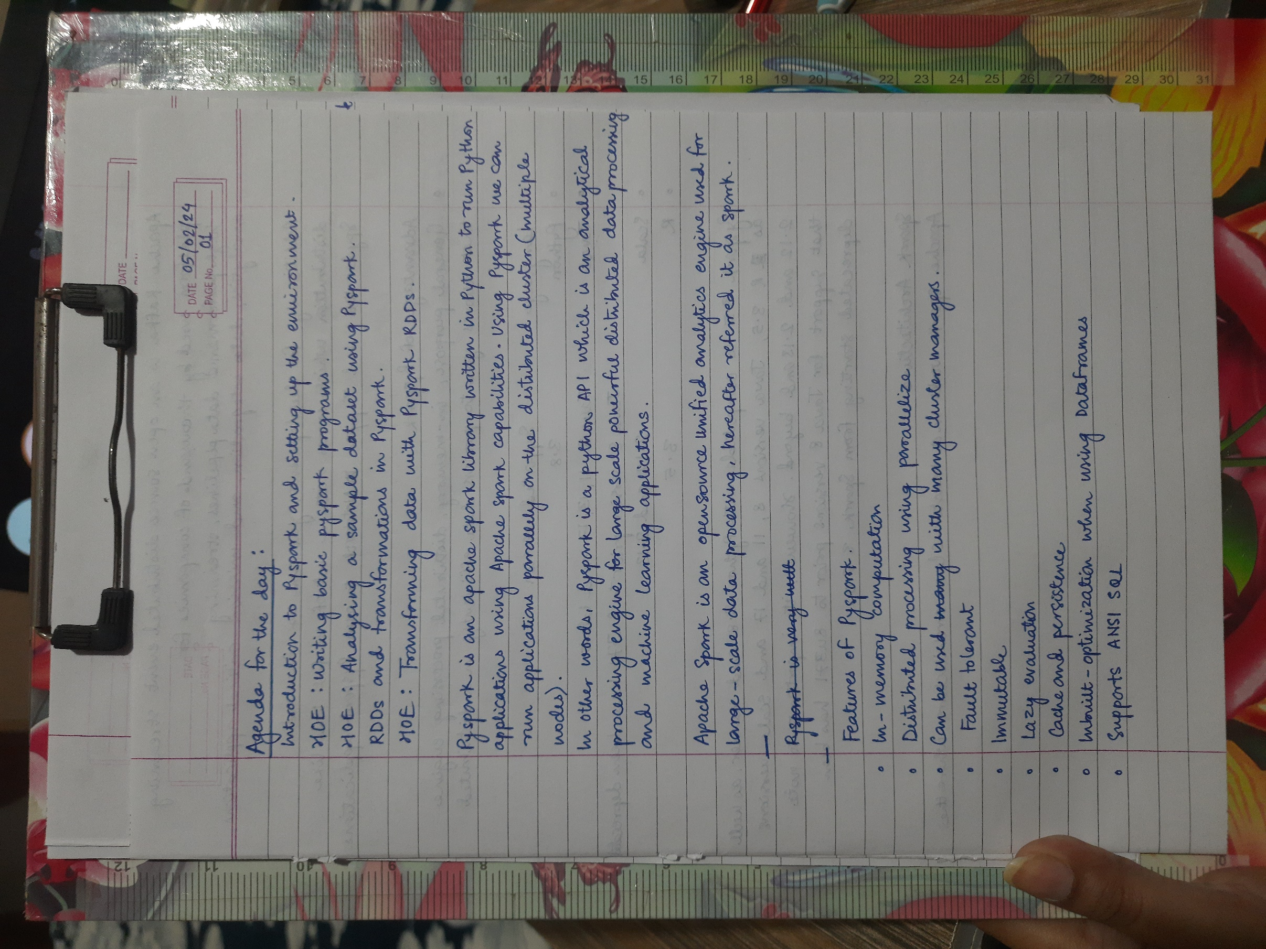

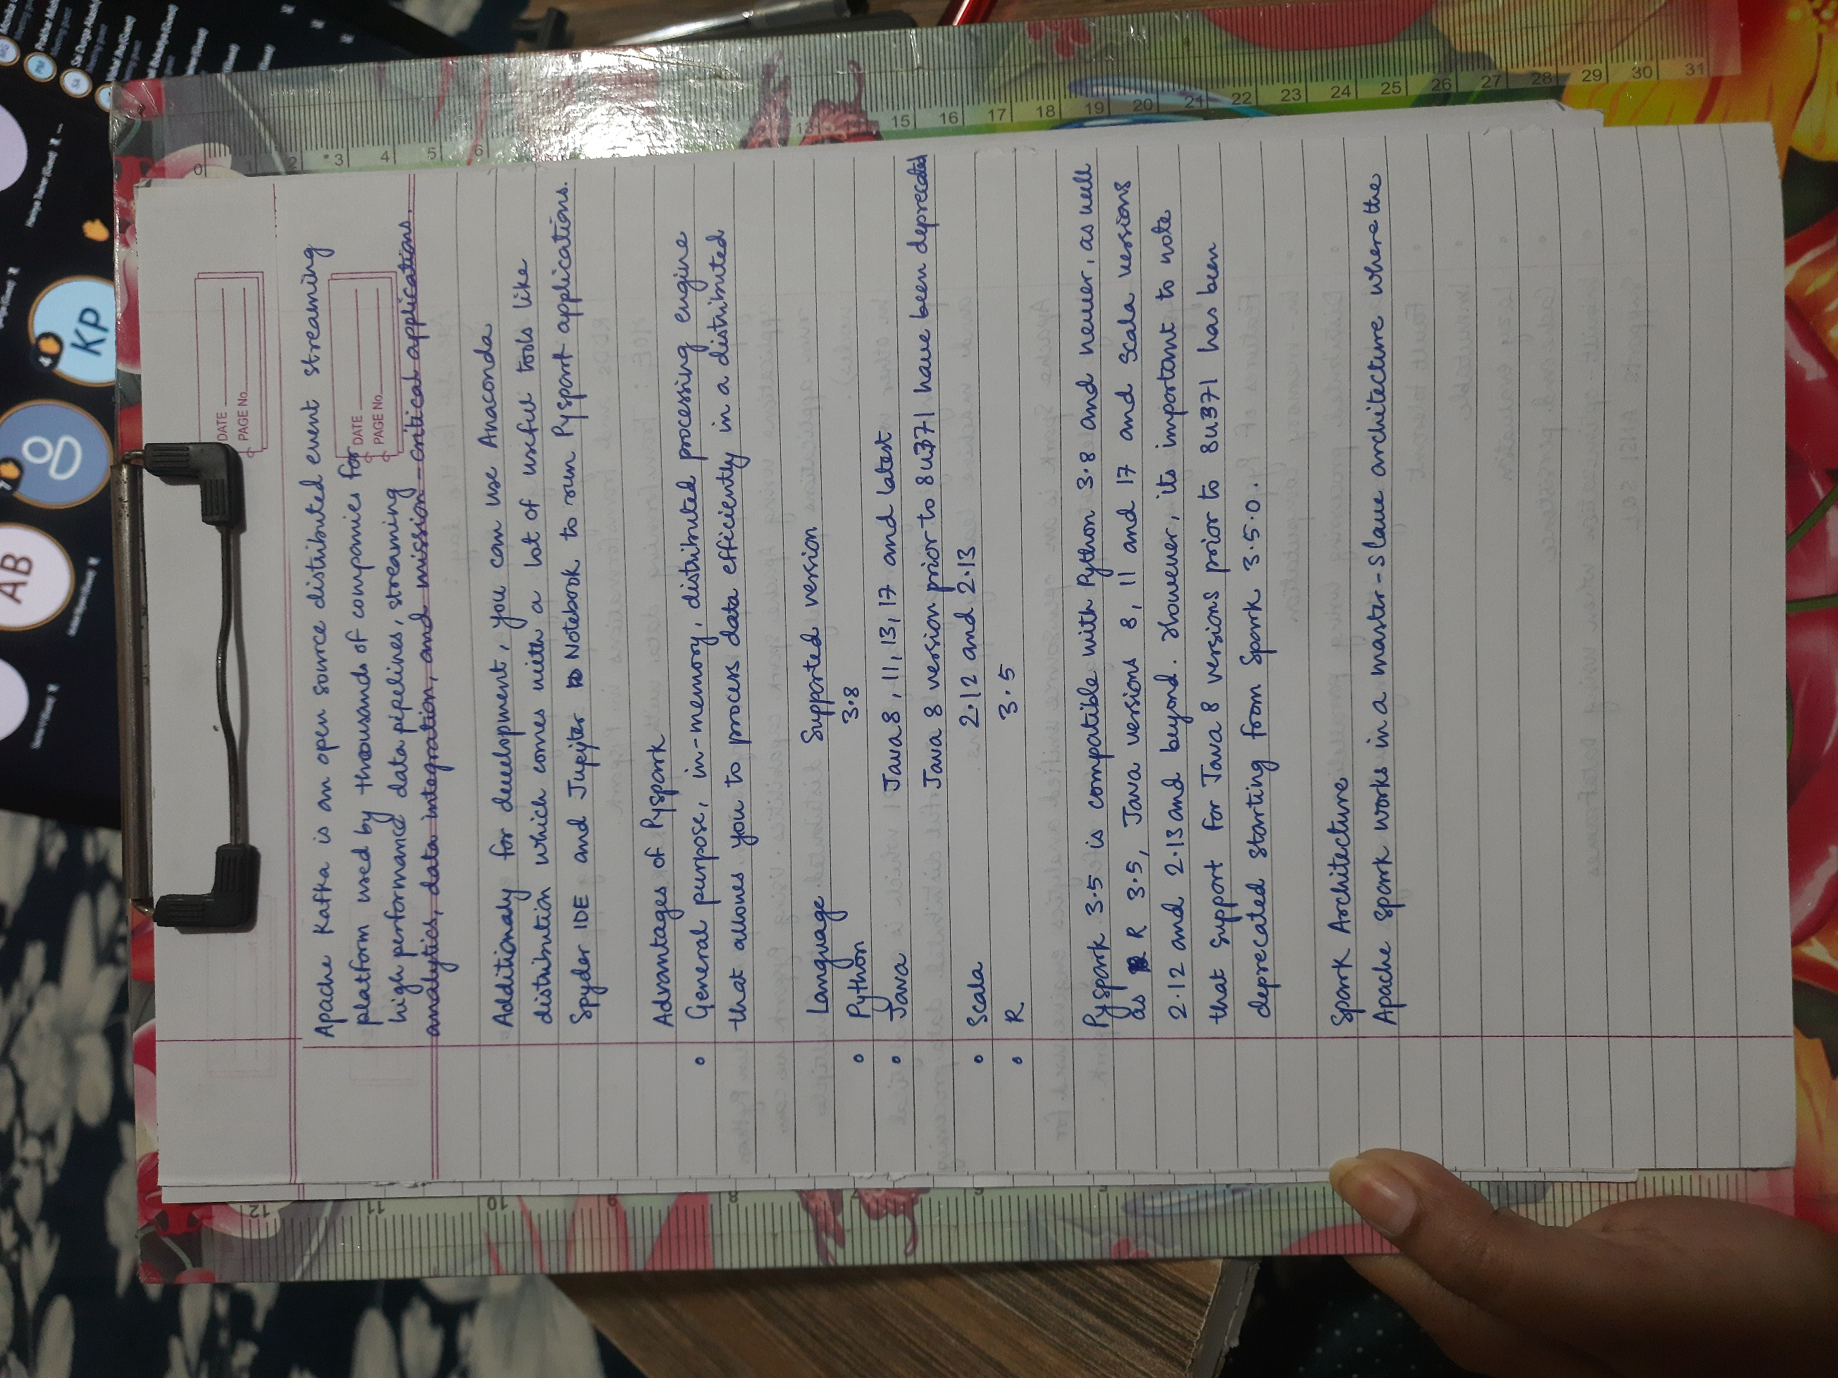

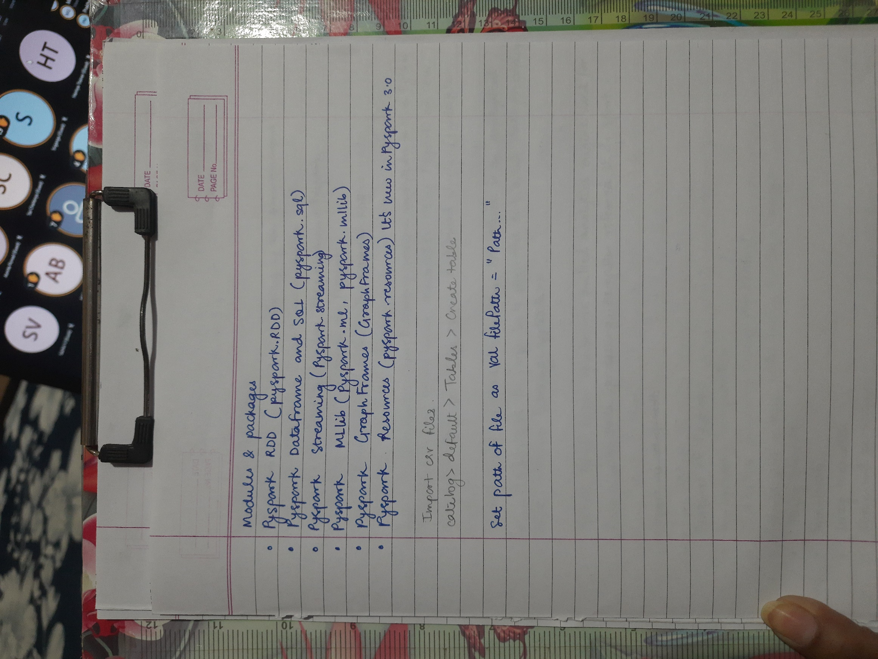

**BASIC PYTSPARK PROGRAMS:**

1. **Reading CSV file in Pyspark:**

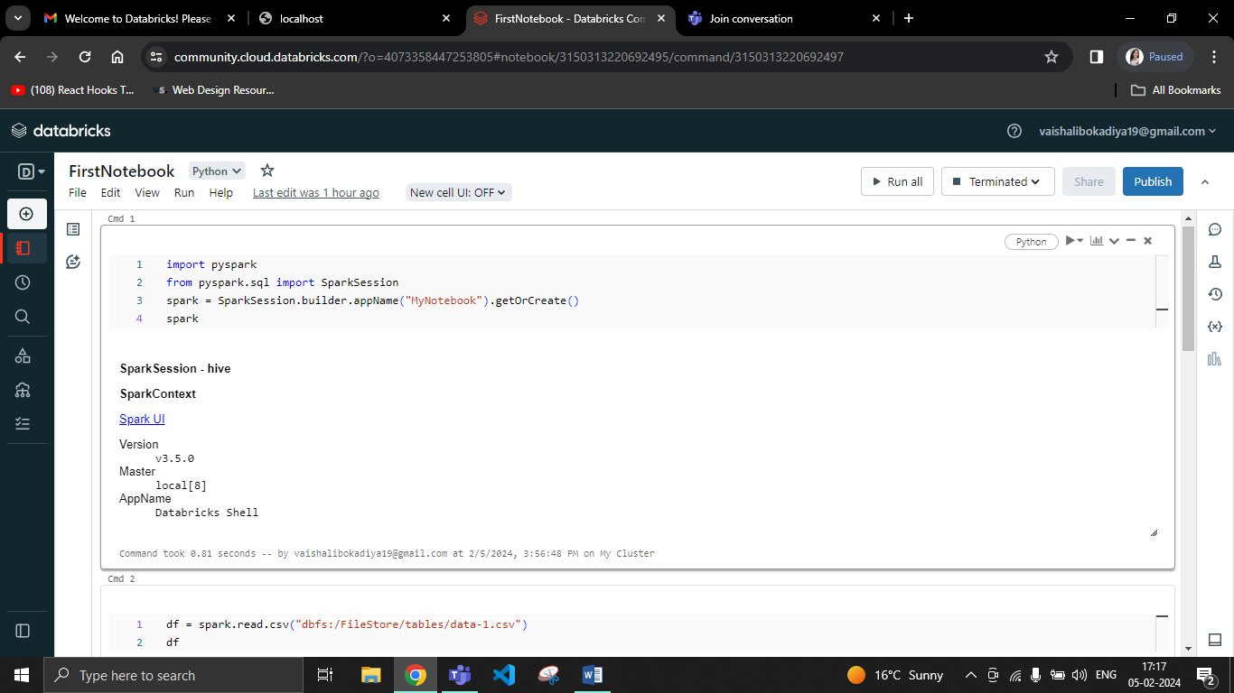

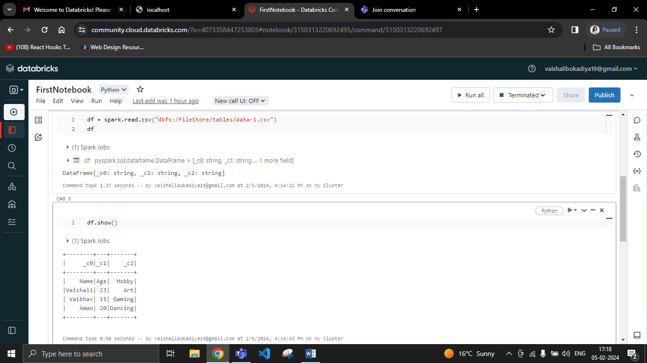

1. **Working with RDD:** Creating RDD, writing into RDD and collecting data from RDD in Pyspark.

